


A Minor Project Report on

AI POWERED GROCERY SHOPPING ASSISTANT

Submitted in partial fulfilment of requirements for the award of the degree of

BACHELOR OF ENGINEERING
in

COMPUTER SCIENCE AND ENGINEERING
Under the guidance of

Mrs .A .SELVANAYAGI
Assistant Professor/CSE

Submitted By

ABINAYA M (927623BCS002) DHANUSUYA K (927623BCS022)

KARENA JONEMARY J (927623BCS042)

DEPARTMENT OF COMPUTER SCIENCE AND ENGINEERING

M.KUMARASAMY COLLEGE OF ENGINEERING
(Autonomous)

KARUR – 639 113
DECEMBER, 2025




M.KUMARASAMY COLLEGE OF ENGINEERING
(Autonomous Institution affiliated to Anna University, Chennai)

KARUR – 639 113

BONAFIDE CERTIFICATE

Certified that this minor project report on “AI POWERED GROCERY SHOPPING ASSISTANT” is the bonafide work of “ABINAYA M (927622BCS002), DHANUSUYA K (927623BCS022), KARENA JONEMARY J (927623BCS042)”, who carried out the project work during the academic year 2023- 2024 under my supervision.

Signature  Mrs. A.SELVANAYAGI  SUPERVISOR  Department of Computer Science and Engineering,  M.Kumarasamy College of Engineering, Thalavapalayam, Karur - 639 113 | Signature  Dr. D.PRADEEP M.E., Ph.D., HEAD OF THE DEPARTMENT  Department of Computer Science and Engineering,  M.Kumarasamy College of Engineering, Thalavapalayam, Karur - 639 113

ii
ii2




DEPARTMENT OF COMPUTER SCIENCE AND ENGINEERING VISION OF THE INSTITUTION
To emerge as a leader among the top institutions in the field of technical education

MISSION OF THE INSTITUTION
- Produce smart technocrats with empirical knowledge who can surmount the global challenges
- Create a diverse, fully-engaged, learner-centric campus environment to provide quality education to the students
- Maintain mutually beneficial partnerships with our alumni, industry, and Professional associations
VISION OF THE DEPARTMENT
To achieve education and research excellence in Computer Science and Engineering

MISSION OF THE DEPARTMENT
- To excel in academic through effective teaching learning techniques

- To promote research in the area of computer science and engineering with the focus on innovation
- To transform students into technically competent professionals with societal and ethical responsibilities
PROGRAM EDUCATIONAL OBJECTIVES (PEOs)
PEO 1: Graduates will have successful career in software industries and R&D divisions through continuous
PEO 2: Graduates will provide effective solutions for real world problems in the key domain of computer
PEO 3: Graduates will excel in their profession by being ethically and socially responsible.

iii
iv




PROGRAM OUTCOMES (POs)

Engineering students will be able to:

- Engineering knowledge: Apply the knowledge of mathematics, science, engineering fundamentals, and an engineering specialization to the solution of complex engineering problems.
- Problem analysis: Identify, formulate, review research literature, and analyze complex engineering problems reaching substantiated conclusions using first principles of mathematics, natural sciences, and engineering sciences.
- Design/development of solutions: Design solutions for complex engineering problems and design system components or processes that meet the specified needs with appropriate consideration for the public health and safety, and the cultural, societal, and environmental considerations.
- Conduct investigations of complex problems: Use research-based knowledge and research methods including design of experiments, analysis and interpretation of data, and synthesis of the information to provide valid conclusions.
- Modern tool usage: Create, select, and apply appropriate techniques, resources, and modern engineering and IT tools including prediction and modeling to complex engineering activities with an understanding of the limitations.
- The engineer and society: Apply reasoning informed by the contextual knowledge to assess societal, health, safety, legal and cultural issues and the consequent responsibilities relevant to the professional engineering practice.
- Environment and sustainability: Understand the impact of the professional engineering solutions in societal and environmental contexts, and demonstrate the knowledge of, and need for sustainable development.
- Ethics: Apply ethical principles and commit to professional ethics and responsibilities and norms of the engineering practice.
- Individual and team work: Function effectively as an individual, and as a member or leader in diverse teams, and in multidisciplinary settings.
- Communication: Communicate effectively on complex engineering activities with the engineering community and with society at large, such as, being able to comprehend and write effective reports and design documentation, make effective presentations, and give and receive clear instructions.




- Project management and finance: Demonstrate knowledge and understanding of the engineering and management principles and apply these to one’s own work, as a member and leader in a team, to manage projects and in multidisciplinary environments.
- Life-long learning: Recognize the need for, and have the preparation and ability to engage in independent and life-long learning in the broadest context of technological change.
PROGRAM SPECIFIC OUTCOMES (PSOs)
  - PSO1: Professional Skills: Ability to apply the knowledge of computing techniques to design and develop computerized solutions for the problems.
  - PSO2: Successful career: Ability to utilize the computing skills and ethical values in creating a successful career.

ABSTRACT

Individuals with visual impairment experience considerable difficulties when shopping independently in retail environments because of the inability to visually identify products, read labels, check prices, and navigate shelves. The Smart Shopping App for Blind People is an assistive mobile solution to allow those who are visually impaired to shop independently, safely, and efficiently. Retail environments create a considerable barrier to shopping independently for blind users. Blind users have difficulty identifying products, reading labels, navigating aisles, and managing contents of shopping lists. The app includes a live product detection function that prompts results in real-time via the camera on the user’s device. This allows blind users to receive immediate audio feedback of the product name and product category. The app also provides live text recognition so users can listen to speech-in-text translation of the product label—features include product price, expiration date, and instructions.

vi
vii




ABSTRACT WITH POs AND PSOs MAPPING

ABSTRACT | POs  MAPPED | PSOs  MAPPED
Individuals with visual impairment experience considerable difficulties when shopping independently in retail environments because of the inability to visually identify products, read labels, check prices, and navigate shelves. The Smart Shopping App for Blind People is an assistive mobile solution to allow those who are visually impaired to shop independently, safely, and efficiently. Retail environments create a considerable barrier to shopping independently for blind users. Blind users have difficulty identifying products, reading labels, navigating aisles, and managing contents of shopping lists. The app includes a live product detection function that prompts results in real-time via the camera on the user’s device. This allows blind users to receive immediate audio feedback of the product name and product category. The app also provides live text recognition so users can listen to speech-in-text translation of the product label—features include product price, expiration date, and instructions. | PO1(2)  PO2(3)  PO3(2)  PO4(2)  PO5(3)  PO6(1)  PO7(3)  PO8(2)  PO9(3) PO10(3) PO11(2) PO12(2) | PSO1(3) PSO2(2)
Note: 1- Low, 2-Medium, 3- High

SUPERVISOR HEAD OF THE DEPARTMENT

vii

TABLE OF CONTENT

CHAPTER No. TITLE PAGE No.
vi ix ix 1
4
4
5
5
6

7
8
1
ABSTRACT vi
LIST OF FIGURES ix
LIST OF ABBREVIATIONS x
- INTRODUCTION 1
  - Survey Undergone 4
  - Target Community 6
  - Problem Identified 8
  - Objectives 8
- LITERATURE SURVEY 9
- PROPOSED METHODOLOGY 11
  - Proposed Methodology 11
  - Proposed Architecture 12
  - Description 15
- MODULES 16
  - Module Description 16
- CONCLUSION 20
APPENDIX I 21
APPENDIX II 31
REFERENCES 38

viii

LIST OF FIGURES
7
8
13
14
15

FIGURE No. | TITLE | PAGE No.
3.1 | Block Diagram | 11
3.2 | Architecture of Application | 12
A.1 | Screenshot of App | 35
A.2 | Screenshot of Instruction | 36
A.3 | Screenshot of Main app | 37
A.4 | Screenshot of Shopping list | 37
A.5 | Screenshot of voice to list | 38

ix

LIST OF ABBREVIATIONS

AI | Artificial Intelligence
API | Application Programming Interface
AR | Augmented Reality
HTML | Hyper Text Markup Language
HTTPS | Hyper Text Transfer Protocol Secure
OCR | Optical character Recognition
TTS | Text-to-Speech
NLP | Natural language processing
JSON | JavaScript Object Notation
STT | Speech-to-Text
APK | Android Package
SQL | Structured Query Language
IDE | Integrated Development Environment
SDK | Software Development Kit
UI | User Interface

x
ix

CHAPTER 1 INTRODUCTION
Shopping independently is a daily challenge for blind and visually impaired individuals due to the lack of accessible product information, reliance on others for assistance, and difficulties in identifying items on shelves. Traditional shopping environments often do not provide sufficient support for visually impaired customers, leading to frustration, uncertainty, and dependence. To address these real-world challenges, the Shopping Assistant Application has been developed as an inclusive, intelligent, and user-centric solution.
The application aims to create a fully accessible digital shopping companion that enables users to shop confidently, safely, and without relying on external help. The interface is intentionally designed with simplicity, clarity, and accessibility as top priorities. The home screen contains only three essential buttons—Read Me, Enter to the App, and QR Code—ensuring ease of use through minimal visual complexity. To further support accessibility, the app incorporates fingerprint authentication, allowing visually impaired users to log in securely without needing textual or visual confirmation.
Once inside the application, users gain access to three major functional modules: Live Product Detection, Take List, and Live Text Recognition.
- The Live Product Detection feature uses the device’s camera and real-time object recognition technology to identify products and announce their names through voice output.
- The Take List module enables users to create, save, edit, and delete shopping lists entirely through voice commands, helping them manage their shopping tasks independently.

- The Live Text Recognition feature converts printed text on labels, packaging, or signage into speech, allowing users to access information that would otherwise be visually unavailable.
2

Overview

The Shopping Assistant application is designed to empower blind and visually impaired users by enabling independent, safe, and confident shopping. With a simple and accessible interface, the app provides voice-guided navigation, fingerprint-secured login, and essential features such as live product detection, shopping list management, text recognition, and QR code scanning. By combining these smart capabilities, the app ensures users can easily identify products, access important information, and manage their shopping tasks without external assistance.

Domain Introduction
The Shopping Assistant application is designed to empower blind and visually impaired users by enabling independent, safe, and confident shopping. With a simple and accessible interface, the app provides voice-guided navigation, fingerprint-secured login, and essential features such as live product detection, shopping list management, text recognition, and QR code scanning. By combining these smart capabilities, the app ensures users can easily identify products, access important information, and manage their shopping tasks without external assistance.

Framework
The Shopping Assistant application is built on a multi-layered framework that integrates accessibility-focused design, mobile computing technologies, and intelligent recognition systems. The framework ensures that the application remains user-friendly, secure, and capable of delivering real-time assistance to blind and visually impaired users. It is organized into four major layers:

The frameworks used for the development of the Application and includes:

- Frontend: Android (JAVA)

- Backend: SQLITE (Database)

Front-End: Java
Java is used as the primary front-end programming language for developing the user interface and application logic of the Shopping Assistant app.
- Native Android Support: Java is one of the official languages for Android app development, ensuring smooth performance and full compatibility with Android APIs.
- Strong UI Integration: Java works seamlessly with XML layouts in Android Studio to create accessible, user-friendly screens.
- Robust Libraries: It provides built-in support for camera access, fingerprint authentication, speech-to-text, text-to-speech, and accessibility services.
- High Stability and Security: Ideal for apps where reliability and secure interactions (like fingerprint login) are crucial.

Back-End: SQLite
SQLite is used as the lightweight, local database system for storing the user’s data within the app.
- Built-in Android Database: SQLite is embedded directly into Android OS, so no external installation is required.
- Fast and Lightweight: Perfect for mobile applications with simple data structures.
- Reliable Local Storage: Works offline, which is essential for blind users who may not always have internet access while shopping.

Software Used: Android Studio
Android Studio is the official IDE (Integrated Development Environment) for building Android apps.
- Complete Development Environment: Provides tools for Java coding, UI design, database handling, and debugging in one place.
- Integrated Emulator: Allows testing of accessibility features, camera functions, voice commands, and QR scanning.
- Support for ML and Vision Libraries: Easily integrates ML Kit, CameraX API, QR scanning libraries, and OCR frameworks.
- Efficient Project Management: Helps organize Java files, XML layouts, database helpers, and resources neatly.

Survey Undergone

1. Senior Citizens:
Many senior citizens struggle with grocery shopping due to weakened eyesight, difficulty reading labels, mobility issues, and lack of confidence in crowded stores. They reported challenges in identifying products, checking expiry dates, and distinguishing similar items. Most participants expressed the need for a simple, voice-assisted system to guide them.
Doctors and caregivers emphasized that senior citizens often rely on family members or staff for assistance in stores. A technology-driven grocery assistant can help them regain independence and reduce dependency.
Important considerations while designing the assistant included ease of use, voice clarity, large icons/text, and data security.

Key User Needs Identified
- Clear and easy voice instructions
- Simple camera-guided product detection
- Automatic expiry date and label reading
- Ability to maintain a voice-controlled shopping list

Desired Features
- Voice-based product identification
- Expiry and safety alerts
- Navigation help within stores
- Shopping summary and reminders

2. Blind People:
Blind users face complete dependence on others for daily grocery shopping. They cannot visually detect items, read product labels, or assess food quality. They expressed strong interest in an AI system that could “see” for them through the camera and provide continuous voice feedback.
Blind participants shared that current tools like screen readers help with digital access but not with real-world shopping. Proper object detection, barcode scanning, and OCR were considered essential.

Key User Needs Identified
- A fully voice-guided interface
- Accurate object detection through the smartphone camera
- Reliable label reading, including expiry dates and ingredients
- Real-time identification of fresh vs spoiled produce

Desired Features
- Voice instructions for scanning and item detection
- Barcode/OCR reading for product details
- Freshness analysis for fruits/vegetables
- Audio-based shopping list updates

3. Visually Impaired People (Partial Vision Loss):
Visually impaired users often struggle with low lighting, small fonts, or similar packaging. They rely partially on vision and partially on external assistance. This group showed high interest in an AI assistant that provides both visual highlights and voice guidance.Most reported difficulty reading pricing, identifying brands, and checking expiry dates. They requested both visual cues (big text, high contrast UI) and clear voice feedback.

Key User Needs Identified
- Combination of visual indicators + voice assistance
- Real-time camera detection to identify items
- Ability to zoom in on product information
- Safe navigation inside stores

Desired Features
- YOLO-based product detection
- Read-aloud feature for labels and dates
- Voice-controlled grocery list
- Alerts for unsafe or expired items

1.2 TargetCommunity
    - Blind Individuals
    - Visually Impaired Users
    - Elderly People with Weak Vision
    - Users with Reading or Literacy Challenges

The primary target community for this Shopping Assistant application is blind and visually impaired individuals who face challenges while shopping independently. This includes people with complete blindness, low vision, or progressive vision loss who require assistive tools for identifying products, reading labels, understanding expiry dates, and navigating store environments. The application also supports individuals with literacy difficulties, elderly users with declining vision, and those who prefer audio-based interaction over visual interfaces. Additionally, organizations and caregivers who work with visually impaired individuals—such as rehabilitation centers, special education institutions, and support groups—also form part of the target community, as the app can serve as a valuable tool for training and daily assistance. Overall, the application is designed to empower visually impaired shoppers by enhancing independence, safety, and confidence during everyday shopping tasks.

3

Problem Identified

Previous projects aimed at assisting blind and visually impaired individuals during shopping revealed several significant limitations that affect usability and independence. Many earlier applications lacked fully accessible interfaces, with poor layouts, unreadable elements, and minimal screen-reader support. Existing systems often focused on a single feature—such as text recognition or object detection—forcing users to switch between multiple apps to meet basic shopping needs. Common issues included unreliable product detection, inaccurate text recognition, and limited or no support for voice-based interactions.
The problems include:

- Lack of Fully Accessible User Interfaces
- Dependence on Manual Input Methods
- Absence of Voice-Guided Shopping Lists
- Inconsistent or No Offline Support
- Inadequate Support for Reading Product Labels
- Insufficient Audio Feedback

Objectives
A fitness food application typically aims to help users achieve their health and fitness goals by providing support in meal planning, nutrition tracking, and making informed food choices.

- To Enable Independent Shopping for Visually Impaired Users
- To Facilitate Secure and Easy Authentication
- To Provide Accurate, Real-Time Product Information
- Support Voice-Based Interaction

8
20

CHAPTER 2 LITERATURE REVIEW
A literature review for this voice-assisted shopping system focuses on research studies related to assistive technologies, OCR-based recognition, AI-driven shopping support, user interaction patterns, and accessibility outcomes. It highlights technological advancements, user needs, and gaps in existing systems.

1. Current Trends and Usage of Assistive Systems
This section provides an overview of the current environment for assistive applications, including adoption trends among visually impaired users, general consumers, and elderly populations. It examines app usage statistics, user engagement patterns, and the growing shift toward voice-first, hands-free systems. Studies show that users prefer applications that reduce physical effort, offer quick product information, and support real-time feedback.

2. Effectiveness of AI-based Object and Text Detection
Research indicates that OCR and object-detection technologies significantly support user independence by identifying items, reading labels, and offering guidance. Studies explore how AI-enabled apps can improve shopping efficiency, reduce dependency on others, and enhance confidence among visually impaired individuals. Key findings highlight that high-accuracy OCR and stable object detection are critical for real-world usability.

3. Features Contributing to Successful Assistive Applications
Reviewing successful systems reveals several essential components:
- Intuitive UI/UX design

- Accurate text recognition and object detection
- Multilingual voice guidance
- Gamification and guided interactions (optional)
- Integration with mobile camera, sensors, and OCR engines
- Strong accessibility support for users with disabilities
4. User Motivation and Engagement Factors
Research on user behavior in assistive technologies highlights the importance of:
- Immediate feedback
- Clear and natural voice responses
- Minimal navigation steps
- Simple and fast product identification
- Consistent accuracy
Developers frequently incorporate motivational strategies such as progress cues, reminders, and user-friendly interactions to ensure continued system usage.
5. Outcomes and Benefits of Using Assistive Shopping Apps
Studies demonstrate that assistive systems help users achieve:
- More confident and independent shopping experiences
- Better understanding of product details (expiry, ingredients, labels)
- Reduced risk of purchasing incorrect or unsafe products
- Enhanced overall safety and convenience
Regular use improves decision-making abilities and quality of life for visually impaired users.

6. Future Directions and Research Opportunities
The literature highlights several gaps and emerging directions:
- Higher accuracy in complex environments
- Improved OCR for multilingual and low-quality labels
- Integration of AR-based guidance
- Enhanced personalization and contextual awareness
- Offline processing for low-internet regions
- Future innovations may involve AI-powered recommendation systems, enhanced sensory feedback, and deeper integration with IoT-based smart shopping platforms.

Conclusion of Literature Review
A comprehensive literature review provides key insights into the importance, effectiveness, challenges, and opportunities associated with voice-assisted shopping applications. These insights guide the development of more accurate, accessible, and user-friendly systems, supporting independent living and improving the overall shopping experience for visually impaired users and others seeking hands-free convenience.

20

CHAPTER 3 PROPOSED SYSTEM

3.1 Proposed Methodology
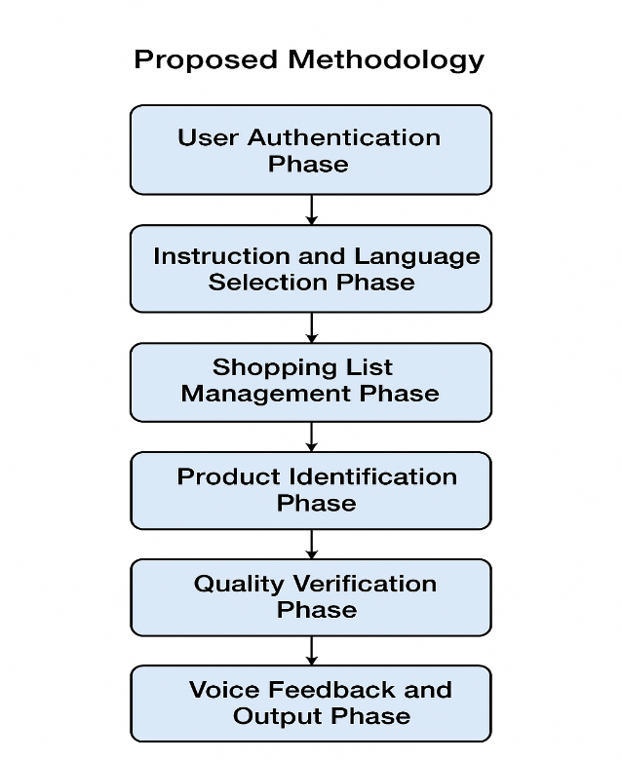

Figure 3.1 Block diagram

The methodology diagram illustrates the complete workflow of the system in a step-by-step manner, beginning from user login and ending with voice-based output. Each phase in the flowchart represents a major functional block of the application.

1. User Authentication Phase
This is the first step where the user accesses the system. The application verifies the user's identity through login credentials and biometric fingerprint authentication. This ensures secure and authorized access before the user proceeds further.

2. Instruction and Language Selection Phase
After authentication, the user is guided through an Instruction module that explains how to use the application. The user then selects a preferred language—such as Tamil or English—so the interface and speech outputs match their comfort and accessibility requirements.

3. Shopping List Management Phase
In this phase, the user manages their shopping items. The system provides functions to add new items, remove unwanted items, and read the entire shopping list aloud. This helps users—especially visually impaired individuals—organize and track the items they need.

4. Product Identification Phase
Once the user begins interacting with real-world items, the system uses object detection, OCR scanning, and QR scanning to identify the product. The application recognizes text labels, product names, brand details, and other important information through the camera.

5. Quality Verification Phase
After identifying the product, the system verifies the item’s quality. This can include checking expiry dates, label clarity, and consistency of detected information. This phase helps users confirm the safety and correctness of the product.

6. Voice Feedback and Output Phase
Finally, the system converts all processed information into audio output using TFLite-based text-to-speech technology. The user receives clear voice feedback about the detected product, list items, or instructions, ensuring complete accessibility and usability.

20
10

Proposed Architecture
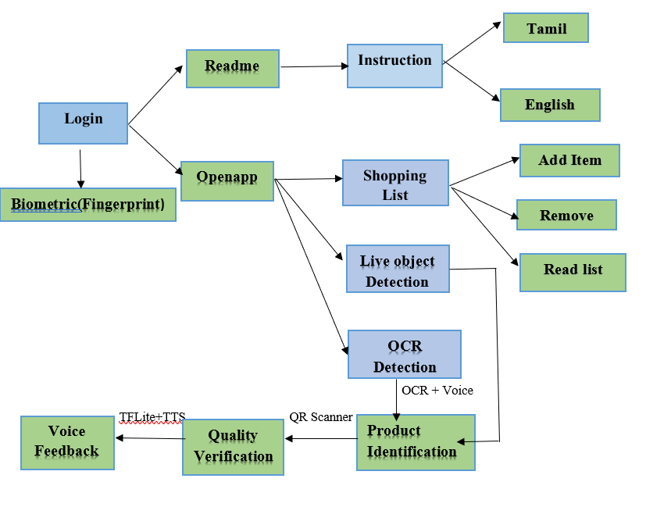

Figure 3.2 Architecture of Application

- Login & Authentication
- Users start by accessing the Login module.
- Secure authentication is provided through Biometric Fingerprint verification.
- Read Me & Instructions
- After login, users can open the Read Me section for guidance.
- The Instruction module explains how to use the application.
- Users can choose their language preference:
Tamil
English
- Main Application – Open App
The Open App option leads the user to all core features of the system.
- Shopping List Management
Users can manage their shopping list through three functions:
Add Item
Remove Item
Read List (voice output of the list)
- Live Object Detection
Uses camera-based detection to identify real-world items.
Helps visually impaired users recognize objects around them.
- OCR Detection
Performs Optical Character Recognition to read text on product labels.
Converts text to speech (OCR + Voice).
- Product Identification
Works with OCR results and QR scanner to identify the product.
Ensures correct recognition of items during shopping.
- Quality Verification
Verifies the product’s quality (freshness, validity, identification accuracy).
Sends results to the voice feedback module.
- Voice Feedback
Uses TFLite + TTS (Text-to-Speech) to deliver information to the user.
Provides spoken instructions, warnings, or confirmation messages.

Description

The system begins with a secure Login process, supported by Biometric Fingerprint authentication to ensure only authorized users access the application. Once authenticated, the user can either view the Read Me section or proceed to Open App, which serves as the central hub for all functionalities.
The Instruction module provides guidance on how to use the application and allows the user to choose their preferred language, either Tamil or English, enhancing usability and accessibility. Through the app interface, the user can manage a Shopping List, which includes options to add items, remove items, and read the list aloud through voice support.For real-world assistance, the system incorporates Live Object Detection, enabling the identification of physical items in front of the user. This works in combination with OCR Detection, which reads printed text on products and translates it into voice output. The system further supports Product Identification using both OCR results and QR scanning features, ensuring accurate recognition of items.To enhance reliability, a Quality Verification module checks the detected item’s details and validity before providing the final confirmation. The Voice Feedback module powered by TFLite +TTS communicates results, instructions, and alerts back to the user, ensuring a smooth and user-friendly experience.

CHAPTER 4 MODULES
The application is built using several integrated modules that work together to provide a smooth and assistive user experience. User Authentication ensures secure access, while the Instruction and Shopping List modules guide users through app navigation and grocery management. Product Identification and Quality Verification help users recognize items and check their freshness. The Voice Feedback Module enhances accessibility by providing clear audio responses, making the app especially helpful for visually impaired users.
      - User Authentication
      - Instruction Module
      - Shopping list module
      - Product identification Module
      - Quality verification Module
      - Voice feedback Module

Module Description

User Authentication:
- The Fingerprint Login Module allows users to securely access the app using their fingerprint. It eliminates the need for typing or remembering passwords, making login easier for blind users. The module verifies the user’s identity quickly through biometric authentication. It ensures high security and prevents unauthorized access. Overall, it provides a fast, safe, and user-friendly login experience.
- Instruction Module :
Use the Read Me option to hear guidance in English and Tamil for easy navigation.Log in using fingerprint authentication for secure, hands-free access.Enter the app to use features like Live Product Detection, Take List, and QR Code scanning with full audio support.

- 3. Shopping list :

  - The Take List Module allows users to add items to their shopping list using voice input. It stores the list safely and lets users delete items through simple voice commands. The module helps visually impaired users manage their shopping items without typing. By long-pressing the screen, users can hear the entire saved list read aloud. Overall, it provides an easy, hands-free method for organizing shopping needs.

- 4. Live text recognition :
The Live Text Recognition Module captures printed text on products using the camera. It converts the detected text into speech, allowing blind users to hear labels, prices, and details. The module helps users understand important product information independently. It works in real time and supports continuous scanning. Overall, it provides an accurate and accessible solution for reading product text aloud.

- 5. Live object detection
The Live Object Detection Module identifies products in real time using the device camera. It uses AI to recognize objects and instantly reads out the product name through audio. The module helps blind users confirm items without needing any visual input. It works continuously as the camera scans the surroundings. Overall, it provides fast, accurate, and hands-free product identification.
6. Quality verification :
The QR Code Scanning Module allows users to scan product QR codes using the camera. It instantly retrieves detailed product information encoded in the QR code. The module reads out details like name, ingredients, and expiry date through audio. It ensures high accuracy and quick response for blind users. Overall, it provides a reliable way to access product information without visual reading.

CHAPTER 5
20

CONCLUSION

The Shopping Assistant app offers an innovative and user-friendly plan that enhances the shopping process behalf of individuals with blindness or low vision. The application addresses significant barriers by providing key features using live object detection, live text recognition, voice-controlled list management, and QR code scanning. In addition, features like a simple, intuitive interface, fingerprint log-in, and instant multilingual audio instructions improve usability to allow individuals to use the application and complete their shopping tasks without visual efforts.The Shopping Assistant application manages to create a more inclusive society through improved independence, increased confidence and enabling the visually impaired to shop in a safe, efficient, and dignified manner.

APPENDIX I

User Authentication:

package com.example.blindershelper
import android.content.Intent
import android.os.Bundle
import android.widget.TextView
import androidx.appcompat.app.AppCompatActivity
import androidx.biometric.BiometricManager
import androidx.biometric.BiometricPrompt
import androidx.core.content.ContextCompat
import java.util.concurrent.Executor
class FingerprintLoginActivity : AppCompatActivity() {
private lateinit var executor: Executor
private lateinit var biometricPrompt: BiometricPrompt
private lateinit var promptInfo: BiometricPrompt.PromptInfo
private lateinit var tvStatus: TextView
override fun onCreate(savedInstanceState: Bundle?) {
super.onCreate(savedInstanceState)
setContentView(R.layout.activity_fingerprint_login)
tvStatus = findViewById(R.id.tvStatus)
// 🔹 Check biometric availability
val biometricManager = BiometricManager.from(this)
when (biometricManager.canAuthenticate(
BiometricManager.Authenticators.BIOMETRIC_STRONG or
BiometricManager.Authenticators.DEVICE_CREDENTIAL
)) {
BiometricManager.BIOMETRIC_SUCCESS ->
tvStatus.text = "Biometric available — ready to authenticate"
BiometricManager.BIOMETRIC_ERROR_NO_HARDWARE ->
tvStatus.text = "No biometric hardware available"
BiometricManager.BIOMETRIC_ERROR_HW_UNAVAILABLE ->
tvStatus.text = "Biometric hardware currently unavailable"
BiometricManager.BIOMETRIC_ERROR_NONE_ENROLLED ->
tvStatus.text = "No biometrics enrolled. Please enroll in device settings."
else -> tvStatus.text = "Biometric not available"
}
// 🔹 Setup biometric prompt
executor = ContextCompat.getMainExecutor(this)
biometricPrompt = BiometricPrompt(this, executor,
object : BiometricPrompt.AuthenticationCallback() {
override fun onAuthenticationError(errorCode: Int, errString: CharSequence) {
super.onAuthenticationError(errorCode, errString)
tvStatus.text = "Auth error: $errString"
}
override fun onAuthenticationSucceeded(result: BiometricPrompt.AuthenticationResult) {
super.onAuthenticationSucceeded(result)
tvStatus.text = "Unlocked! 🎉"
onAuthenticated()
}
override fun onAuthenticationFailed() {
super.onAuthenticationFailed()
tvStatus.text = "Auth failed — try again"
}
})
// 🔹 Prompt info
promptInfo = BiometricPrompt.PromptInfo.Builder()
.setTitle("Sign in")
.setSubtitle("Use your fingerprint, face or device credential")
.setNegativeButtonText("Use account password") // needed if not using DEVICE_CREDENTIAL
.build()
// 🔹 Authenticate immediately on start
biometricPrompt.authenticate(promptInfo)
}
private fun onAuthenticated() {
// ✅ Move to main/home activity after success
val intent = Intent(this, ChooseWayActivity::class.java)
startActivity(intent)
finish()
}
}

Instruction module:

package com.example.blindershelper
import android.os.Bundle
import android.speech.tts.TextToSpeech
import android.widget.Toast
import androidx.appcompat.app.AppCompatActivity
import com.google.android.material.button.MaterialButton
import java.util.*
class ReadMeOptions : AppCompatActivity(), TextToSpeech.OnInitListener {
private lateinit var tts: TextToSpeech
private lateinit var btnEnglish: MaterialButton
private lateinit var btnTamil: MaterialButton
private var isTtsReady = false
private val englishText = """
Hey there! Welcome to Blinders Helper — this little app is made just for you.
It’s here to help you do things more easily, even if you can’t see what’s on the screen.
When you open the app, you’ll find two big buttons.
The first one is at the top half of the screen.
If you tap that, you’ll enter a small welcome page that says,
Hi there, you’re here now!
The second button is on the bottom half.
If you tap that one, it’ll take you to the main home page of the app.
Once you’re in the home page, you’ll hear that there are three buttons waiting for you:
Live Object Detection at the top,
Take List in the middle,
and Live Text Recognition at the bottom.
The Live Object Detection button uses your camera to recognize fruits and vegetables.
Sometimes it might make mistakes, but it’s trying its best.
The Take List button lets you say your grocery list by voice.
Tap anywhere and speak what you need — like Rice, Milk, or Apples.
Long press anywhere to hear your list read out loud.
And if you want to clear the list, just say Delete All.
The Live Text Recognition button helps you read text on products or papers.
Point your camera at a packet or cover — it’ll read out what it sees,
like Three Roses or Aashirvaad.
That’s all! This app is made to speak, listen, and see for you —
so you can move through your day more easily.
Welcome to Blinders Helper, your smart little buddy that’s always ready to help.
""".trimIndent()
private val tamilText = """
வணக்கம்! இது பிளைண்டர்ஸ் ஹெல்பர் ஆப். உங்களை உதவிக்காக வடிவமைக்கப்பட்ட சிறிய நண்பன்.
இந்த ஆப்பை திறந்தவுடன் இரண்டு பெரிய பொத்தான்கள் இருக்கும்.
முதல் பொத்தான் மேல்பகுதியில் இருக்கும். அதை அழுத்தினால்,
‘ஹாய்! நீ இங்கே இருக்கிறாய்!’ என்று சொல்லும் ஒரு சிறிய பக்கத்துக்கு செல்வீர்கள்.
இரண்டாவது பொத்தான் கீழே இருக்கும்.
அதை அழுத்தினால், ஆப்பின் முகப்புப் பக்கத்துக்கு செல்வீர்கள்.
அந்த முகப்புப் பக்கத்தில் மூன்று பொத்தான்கள் இருக்கும் —
மேலே ‘லைவ் ஆப்ஜெக்ட் டெடெக்ஷன்’,
நடுத்தில் ‘டேக் லிஸ்ட்’,
கீழே ‘லைவ் டெக்ஸ்ட் ரெகக்னிஷன்’.
‘லைவ் ஆப்ஜெக்ட் டெடெக்ஷன்’ பொத்தான் உங்கள் கேமரா மூலமாக காய்கறி, பழங்களை கண்டறியும்.
சில சமயம் தவறாகக் கூறும், ஆனால் முயற்சி செய்கிறது.
‘டேக் லிஸ்ட்’ பொத்தான் உங்கள் மளிகைப் பட்டியலை வாய்வழியாக சேர்க்க உதவும்.
ஸ்கிரீனில் எங்காவது தொடுங்கள், பின்னர் நீங்கள் வாங்க வேண்டிய பொருட்களை சொல்லுங்கள்.
நீங்கள் நீண்ட நேரம் அழுத்தினால் பட்டியலில் உள்ள பொருட்கள் ஒலியாக வாசிக்கப்படும்.
நீங்கள் “எல்லாம் அழி” என்று சொன்னால் பட்டியல் முழுவதும் நீங்கும்.
‘லைவ் டெக்ஸ்ட் ரெகக்னிஷன்’ பொத்தான் பொருட்களில் உள்ள எழுத்துகளைப் படிக்கும்.
உங்கள் கேமராவை எந்த பொருளின் மேல் வைத்தாலும், அதில் உள்ள பெயரை சொல்லும்.
உதாரணமாக — ‘த்ரீ ரோசஸ்’, ‘ஆசிர்வாத்’ போன்றவை.
இதுதான் பிளைண்டர்ஸ் ஹெல்பர் ஆப் — பேசும், கேட்கும், பார்க்கும் நண்பன்.
உங்கள் நாளை எளிதாகவும் சுயமாகவும் மாற்ற உதவுகிறது.
""".trimIndent()
override fun onCreate(savedInstanceState: Bundle?) {
super.onCreate(savedInstanceState)
setContentView(R.layout.activity_readme_option)
tts = TextToSpeech(this, this)
btnEnglish = findViewById(R.id.btnEnglish)
btnTamil = findViewById(R.id.btnTamil)
btnEnglish.setOnClickListener {
if (isTtsReady) {
tts.language = Locale.US
tts.setSpeechRate(0.7f) // slower for better hearing
tts.speak(englishText, TextToSpeech.QUEUE_FLUSH, null, null)
} else {
Toast.makeText(this, "TTS not ready yet", Toast.LENGTH_SHORT).show()
}
}
btnTamil.setOnClickListener {
if (isTtsReady) {
tts.language = Locale("ta", "IN")
tts.setSpeechRate(0.7f)
tts.speak(tamilText, TextToSpeech.QUEUE_FLUSH, null, null)
} else {
Toast.makeText(this, "TTS not ready yet", Toast.LENGTH_SHORT).show()
}
}
}
override fun onInit(status: Int) {
isTtsReady = status == TextToSpeech.SUCCESS
if (!isTtsReady) {
Toast.makeText(this, "Text-to-Speech initialization failed", Toast.LENGTH_SHORT).show()
}
}
override fun onDestroy() {
if (::tts.isInitialized) {
tts.stop()
tts.shutdown()
}
super.onDestroy()
}
}

DataBase Helper:
package com.example.blindershelper
import android.content.ContentValues
import android.content.Context
import android.database.sqlite.SQLiteDatabase
import android.database.sqlite.SQLiteOpenHelper
import java.util.Locale
class DBHelper(context: Context) :
SQLiteOpenHelper(context, "grocery.db", null, 2) { // bumped version to force recreate
override fun onCreate(db: SQLiteDatabase) {
db.execSQL(
"CREATE TABLE grocery(" +
"id INTEGER PRIMARY KEY AUTOINCREMENT, " +
"name TEXT UNIQUE)"
)
}
override fun onUpgrade(db: SQLiteDatabase, oldVersion: Int, newVersion: Int) {
db.execSQL("DROP TABLE IF EXISTS grocery")
onCreate(db)
}
fun insertItem(name: String) {
val db = writableDatabase
val values = ContentValues().apply {
put("name", name)
}
db.insertWithOnConflict(
"grocery",
null,
values,
SQLiteDatabase.CONFLICT_IGNORE
)
db.close()
}
fun getAllItems(): ArrayList<GroceryItem> {
val list = ArrayList<GroceryItem>()
val db = readableDatabase
val cursor = db.rawQuery("SELECT * FROM grocery", null)
if (cursor.moveToFirst()) {
do {
val id = cursor.getInt(cursor.getColumnIndexOrThrow("id"))
val name = cursor.getString(cursor.getColumnIndexOrThrow("name"))
list.add(GroceryItem(id, name))
} while (cursor.moveToNext())
}
cursor.close()
db.close()
return list
}
fun deleteItemByName(name: String): Boolean {
val db = writableDatabase
val rowsDeleted = db.delete(
"grocery",
"LOWER(name)=?",
arrayOf(name.lowercase(Locale.getDefault()))
)
db.close()
return rowsDeleted > 0
}
fun clearAll() {
val db = writableDatabase
db.execSQL("DELETE FROM grocery")
db.close()
}
}

QR reader Module:

package com.example.blindershelper
import android.os.Bundle
import android.os.Vibrator
import android.speech.tts.TextToSpeech
import androidx.appcompat.app.AppCompatActivity
import androidx.camera.core.*
import androidx.camera.lifecycle.ProcessCameraProvider
import androidx.core.content.ContextCompat
import com.google.mlkit.vision.barcode.BarcodeScannerOptions
import com.google.mlkit.vision.barcode.BarcodeScanning
import com.google.mlkit.vision.barcode.common.Barcode
import com.google.mlkit.vision.common.InputImage
import java.util.Locale
class QrReader : AppCompatActivity() {
private lateinit var tts: TextToSpeech
private lateinit var previewView: androidx.camera.view.PreviewView
private var lastScanned = ""
private var cameraProvider: ProcessCameraProvider? = null
override fun onCreate(savedInstanceState: Bundle?) {
super.onCreate(savedInstanceState)
setContentView(R.layout.activity_qr_reader)
previewView = findViewById(R.id.previewView)
tts = TextToSpeech(this) { status ->
if (status == TextToSpeech.SUCCESS) {
tts.language = Locale("en", "IN")
tts.setPitch(1.0f)
tts.setSpeechRate(0.8f)
speak("Camera activated, point at QR code")
}
}
// Camera Provider
val cameraProviderFuture = ProcessCameraProvider.getInstance(this)
cameraProviderFuture.addListener({
cameraProvider = cameraProviderFuture.get()
startCamera()
}, ContextCompat.getMainExecutor(this))
}
private fun startCamera() {
val preview = Preview.Builder().build().also {
it.setSurfaceProvider(previewView.surfaceProvider)
}
val cameraSelector = CameraSelector.DEFAULT_BACK_CAMERA
val scanner = BarcodeScanning.getClient(
BarcodeScannerOptions.Builder()
.setBarcodeFormats(Barcode.FORMAT_QR_CODE)
.build()
)
val analyzer = ImageAnalysis.Builder().build().also { analysis ->
analysis.setAnalyzer(ContextCompat.getMainExecutor(this)) { imageProxy ->
processImage(scanner, imageProxy)
}
}
cameraProvider?.bindToLifecycle(this, cameraSelector, preview, analyzer)
}
private fun processImage(scanner: com.google.mlkit.vision.barcode.BarcodeScanner, imageProxy: ImageProxy) {
val mediaImage = imageProxy.image
if (mediaImage != null) {
val image = InputImage.fromMediaImage(mediaImage, imageProxy.imageInfo.rotationDegrees)
scanner.process(image)
.addOnSuccessListener { barcodes ->
for (barcode in barcodes) {
val value = barcode.rawValue ?: continue
if (value != lastScanned) {
lastScanned = value
vibrate()
speak("QR detected: $value")
}
}
}
.addOnFailureListener { }
.addOnCompleteListener { imageProxy.close() }
} else {
imageProxy.close()
}
}
private fun speak(text: String) {
tts.speak(text, TextToSpeech.QUEUE_FLUSH, null, null)
}
private fun vibrate() {
val vibrator = getSystemService(VIBRATOR_SERVICE) as Vibrator
vibrator.vibrate(100) // short buzz
}
override fun onDestroy() {
tts.shutdown()
cameraProvider?.unbindAll()
super.onDestroy()
}
}

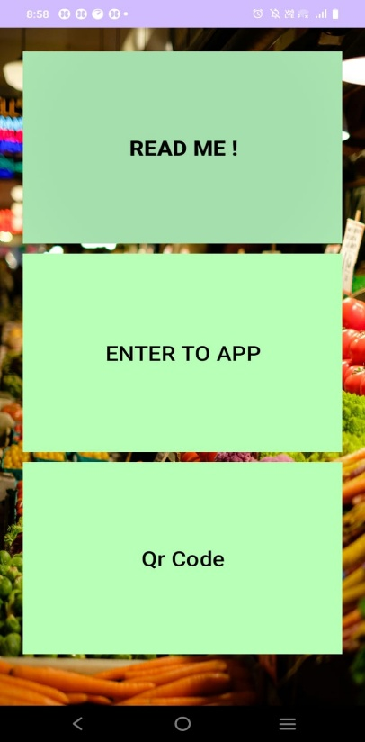

Figure A.5 Screenshot of App
The image shows the home screen of a mobile application with three large buttons: “READ ME!”, “ENTER TO APP”, and “QR Code”. The background features a colorful market scene with fresh vegetables.

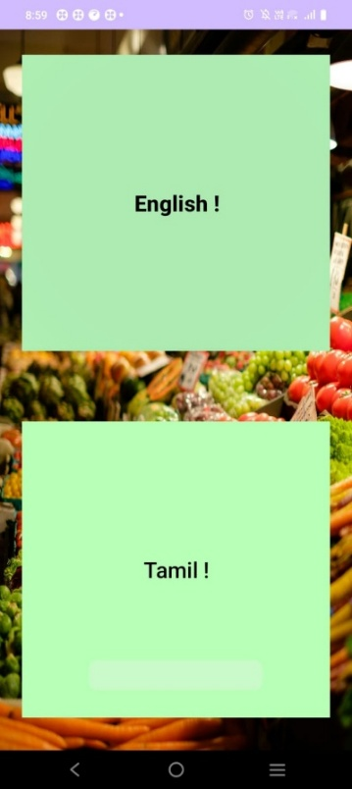

Figure A.6 Screenshot of Instruction
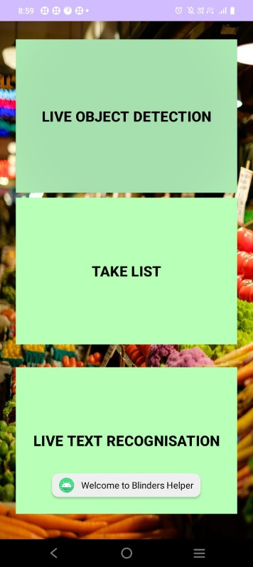
The image shows a language selection screen with two large buttons labeled “English!” and “Tamil!”. The background features a vibrant market scene filled with fresh vegetables.

Figure A.7 Screenshot of Main app

The image displays the app’s feature menu, showcasing three major options: Live Object Detection, Take List, and Live Text Recognition. The buttons are large and easily accessible, set against a colorful background of fresh vegetables

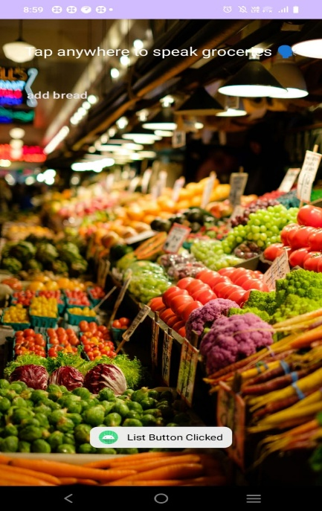

Figure A.8 Screenshot of Shopping List

The image shows a grocery market scene used as the background of the app’s voice-input screen, where users can tap anywhere to speak grocery items. A small message indicating “List Button Clicked” appears at the bottom.
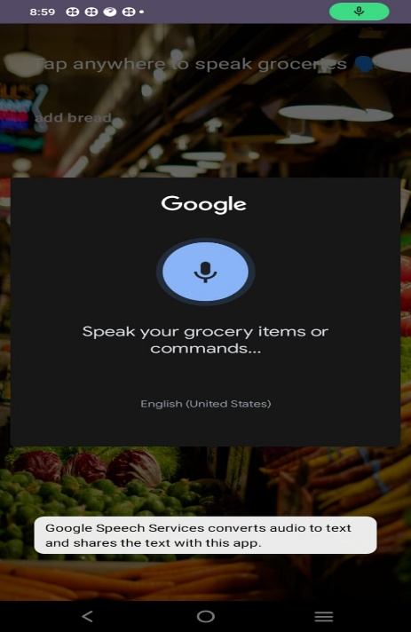

Figure A.9 Screenshot of voice to list

The image shows the Google voice input interface prompting the user to speak grocery items or commands. The microphone icon is displayed prominently over a dark pop-up, with the grocery market background visible behind it.

20
REFERENCES

- R.Shibata, et al., “An AI-Based Shooping Assistant System to Support thr Visually Impaired,” arXiv preprint arXiv:2501,xxxxx, 2025.
- P.Deshmukh, et a;., “SANIP: Shopping Assistsnt and Navigation for the Visually Impaired,” arXiv prreprint arXiv:2207.xxxxx,2022.
- T.George,et al., “Fibe-Grained Product Class Recognition for Assisted Shopping,” arXiv preprint arXiv:1503.xxxxx,2015.
- S.Kumar, et al., “Indoor Navigation and Product RecognitionforBlind People Assisted Shopping,” ResearchGate,2019.
- V.Kulyukin and A. Kutiyanawala, “Accessible Shopping Systems for Blind and Visually Impaired Individuals: Design Requirements and the State of the Art,”ResearchGate,2018.
- P.Shete, M.Shaikh,and R.Sawant,”Smart Shopping Cart for Visually Impaired Individuals,” Conscientia Beam,2022.
- Y.Li et a;., “Fruit Freshness Detection Based on Multi-Task Convolutional Neural Networks,” Journal of Food Engineering, ScienceDirect,2021.
- H.Zhang,et al., “Vegetable and Fruit Freshness Detection Based on Deep Features and Machine Learning Methods,” Peer-Reviewed Medical & Clinical Research (PMC),2020.
- A.Patel,et al., “IoT Based Fruituality Insepection and Lifespan Detection System,” ResearchGate, 2021.
- J.Chen,et al., “ShelfHelp: Empowering Humans to Perform Vision-Independent Manipulation Tasks with a Socially Assistive Robotic Cane,” ACM/IEEE International Conference on Human-Robot Interaction (HRI),2023.

38
20
48

